**Final Ödevi**

**Öğrenci Ad ve Soyad:** Nurdan YILDIRIM

**Öğrenci Numarası:** 20070540028

**Bölüm/Program Adı:** Moda Tasarım

**Ders Adı:** Temel Bilgisayar

**Gönderilme Tarihi:** 20.01.2021

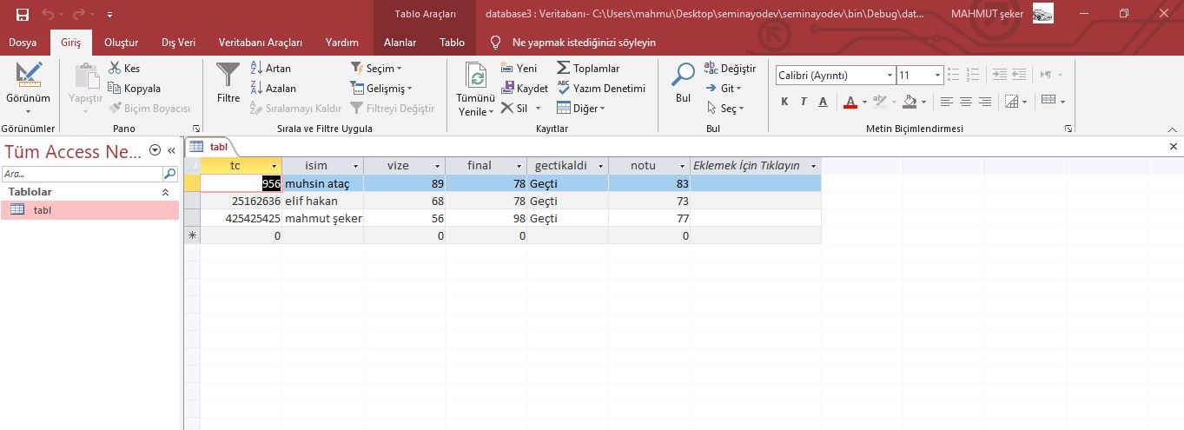Acces Görüntüleri

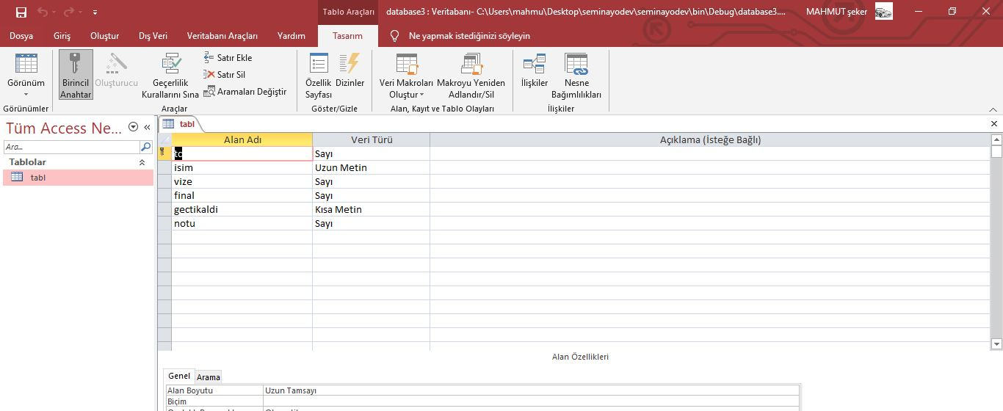

**Kodlar ve Program Çalıştığında gelen form ekranları**

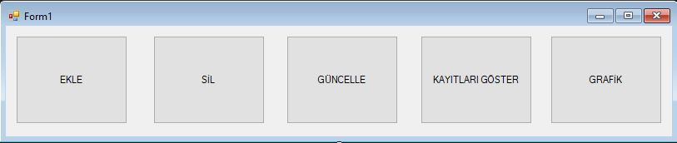Menü:

using System;

using System.Collections.Generic;

using System.ComponentModel;

using System.Data;

using System.Drawing;

using System.Linq;

using System.Text;

using System.Threading.Tasks;

using System.Windows.Forms;

namespace odev

{

public partial class Form1 : Form

{

public Form1()

{

InitializeComponent();

}

private void button1_Click(object sender, EventArgs e)

{

ekle ekle = new ekle();

ekle.Show();

this.Hide();

}

private void ekle_FormClosing(object sender, FormClosingEventArgs e)

{

Application.Exit();

}

private void Form1_FormClosing(object sender, FormClosingEventArgs e)

{

Application.Exit();

}

private void button4_Click(object sender, EventArgs e)

{

listele listele = new listele();

listele.Show();

this.Hide();

}

private void button2_Click(object sender, EventArgs e)

{

sil sil = new sil();

sil.Show();

this.Hide();

}

private void button3_Click(object sender, EventArgs e)

{

guncelle guncelle = new guncelle();

guncelle.Show();

this.Hide();

}

private void button5_Click(object sender, EventArgs e)

{

grafik grafik = new grafik();

grafik.Show();

this.Hide();

}

private void Form1_Load(object sender, EventArgs e)

{

}

}

}

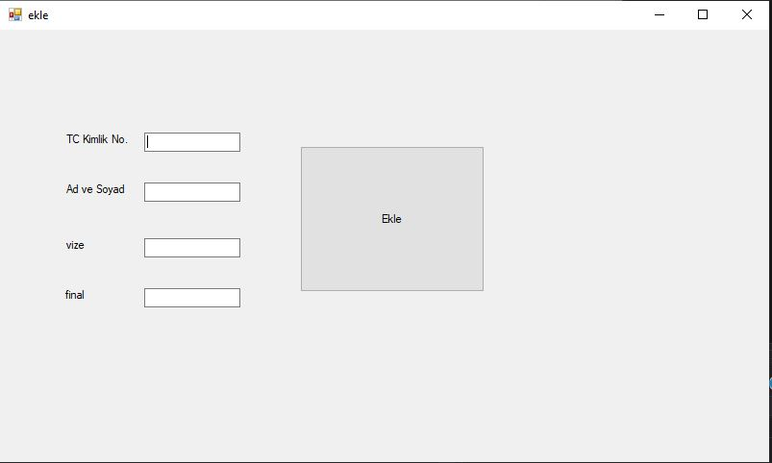Ekle:

using System;

using System.Collections.Generic;

using System.ComponentModel;

using System.Data;

using System.Drawing;

using System.Linq;

using System.Text;

using System.Threading.Tasks;

using System.Windows.Forms;

using System.Data.OleDb;

namespace odev

{

public partial class ekle : Form

{

OleDbConnection baglanti = new OleDbConnection("Provider=Microsoft.ACE.OLEDB.16.0; Data Source="+Application.StartupPath+"\\database3.accdb");

public ekle()

{

InitializeComponent();

}

private void ekle_Load(object sender, EventArgs e)

{

}

private void button1_Click(object sender, EventArgs e)

{

string gectikaldi = "";

int sonuc = 0;

int vize2 = 0, final2 = 0;

vize2 = Convert.ToInt32(textBox3.Text);

final2 = Convert.ToInt32(textBox4.Text);

sonuc = vize2 + final2;

sonuc = sonuc / 2;

if (sonuc < 60)

{

gectikaldi = "Kaldı";

}

else if (sonuc >= 60)

{

gectikaldi = "Geçti";

}

baglanti.Open();

string ekle = "insert into tabl (tc,isim,vize,final,gectikaldi,notu) values (@tc,@isim,@vize,@final,@gectikaldi,@notu)";

OleDbCommand komut = new OleDbCommand(ekle, baglanti);

komut.Parameters.AddWithValue("@tc", textBox1.Text);

komut.Parameters.AddWithValue("@isim", textBox2.Text);

komut.Parameters.AddWithValue("@vize", textBox3.Text);

komut.Parameters.AddWithValue("@final", textBox4.Text);

komut.Parameters.AddWithValue("@gectikaldi", gectikaldi);

komut.Parameters.AddWithValue("@notu", sonuc);

komut.ExecuteNonQuery();

MessageBox.Show("kayıt başarıyla tamamlandı"+vize2);

baglanti.Close();

}

}

}

Sil:

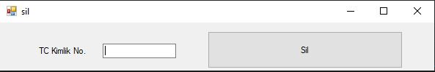

public partial class sil : Form

{

OleDbConnection baglanti = new OleDbConnection("Provider=Microsoft.ACE.OLEDB.16.0; Data Source=" + Application.StartupPath + "\\database3.accdb");

public sil()

{

InitializeComponent();

}

private void button1_Click(object sender, EventArgs e)

{

baglanti.Open();

OleDbCommand komut = new OleDbCommand("detece from tabl where tc='"+textBox1.Text+"'",baglanti);

komut.ExecuteNonQuery();

MessageBox.Show("öğrenci başarıyla silindi");

baglanti.Close();

}

}

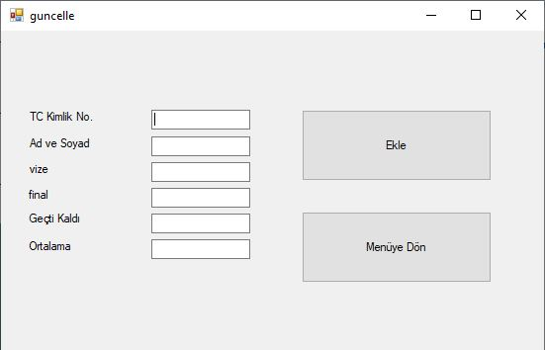Güncelle:

using System;

using System.Collections.Generic;

using System.ComponentModel;

using System.Data;

using System.Drawing;

using System.Linq;

using System.Text;

using System.Threading.Tasks;

using System.Windows.Forms;

using System.Data.OleDb;

namespace odev

{

public partial class guncelle : Form

{

OleDbConnection baglanti = new OleDbConnection("Provider=Microsoft.ACE.OLEDB.16.0; Data Source=" + Application.StartupPath + "\\database3.accdb");

public guncelle()

{

InitializeComponent();

}

private void button2_Click(object sender, EventArgs e)

{

Form1 form1 = new Form1();

form1.Show();

this.Hide();

}

private void button1_Click(object sender, EventArgs e)

{

baglanti.Open();

OleDbCommand komut = new OleDbCommand("update tabl set tc='"+textBox1.Text+"', isim='"+textBox2.Text+"', vize='"+textBox3.Text+"', final='"+textBox4.Text+"', gectikaldi='"+textBox5.Text+"', notu='"+textBox6.Text+"' where tc='"+textBox1.Text+"'",baglanti);

komut.ExecuteNonQuery();

MessageBox.Show("öğrenci bilgileri başarıyla güncellendi");

baglanti.Close();

}

private void textBox1_TextChanged(object sender, EventArgs e)

{

baglanti.Open();

OleDbCommand komut = new OleDbCommand("select * from tabl where tc LIKE'" + textBox1.Text.ToString() + "'", baglanti);

OleDbDataReader okuyucu = komut.ExecuteReader();

while (okuyucu.Read())

{

textBox2.Text = okuyucu["isim"].ToString();

textBox3.Text = okuyucu["vize"].ToString();

textBox4.Text = okuyucu["final"].ToString();

textBox5.Text = okuyucu["gectikaldi"].ToString();

textBox6.Text = okuyucu["notu"].ToString();

}

baglanti.Close();

}

}

}

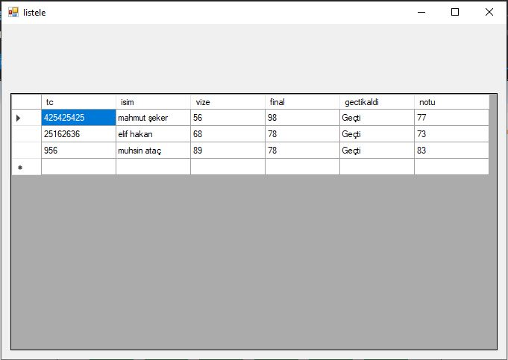Listele:

using System;

using System.Collections.Generic;

using System.ComponentModel;

using System.Data;

using System.Drawing;

using System.Linq;

using System.Text;

using System.Threading.Tasks;

using System.Windows.Forms;

using System.Data.OleDb;

namespace odev

{

public partial class listele : Form

{

OleDbConnection baglanti = new OleDbConnection("Provider=Microsoft.ACE.OLEDB.16.0; Data Source=" + Application.StartupPath + "\\database3.accdb");

DataTable tablo = new DataTable();

public listele()

{

InitializeComponent();

}

private void listele_Load(object sender, EventArgs e)

{

baglanti.Open();

OleDbDataAdapter adaptr = new OleDbDataAdapter("select * from tabl", baglanti);

adaptr.Fill(tablo);

dataGridView1.DataSource = tablo;

baglanti.Close();

}

}

}

Grafik:

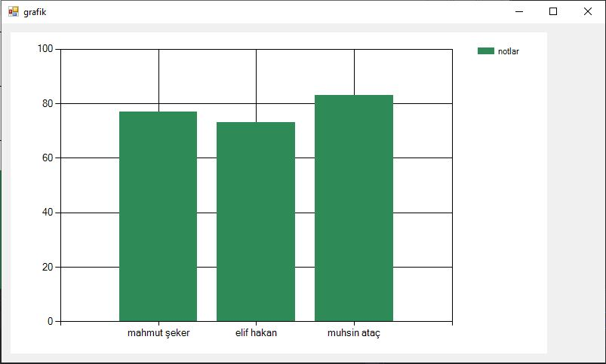

namespace odev

{

public partial class grafik : Form

{

OleDbConnection baglanti = new OleDbConnection("Provider=Microsoft.ACE.OLEDB.16.0; Data Source=" + Application.StartupPath + "\\database3.accdb");

public grafik()

{

InitializeComponent();

}

private void grafik_Load(object sender, EventArgs e)

{

baglanti.Open();

OleDbCommand komut = new OleDbCommand("select isim,notu from tabl", baglanti);

OleDbDataReader oku = komut.ExecuteReader();

while(oku.Read())

{

chart1.Series["notlar"].Points.AddXY(oku[0].ToString(), oku[1].ToString());

}

baglanti.Close();

}

}

}